**Project Design Phase-II**

**Data Flow Diagram & User Stories**

|  |  |
| --- | --- |
| Date | 23 October 2022 |
| Team ID | PNT2022TMID47203 |
| Project Name | Visualizing and Predicting Heart Disease with Interactive Dashboard |
| Maximum Marks | 4 Marks |

**Data Flow Diagrams:**

A Data Flow Diagram (DFD) is a traditional visual representation of the information flows within a system. A neat and clear DFD can depict the right amount of the system requirement graphically. It shows how data enters and leaves the system, what changes the information, and where data is stored.

**Example:** [**(Simplified)**](https://developer.ibm.com/patterns/visualize-unstructured-text/)

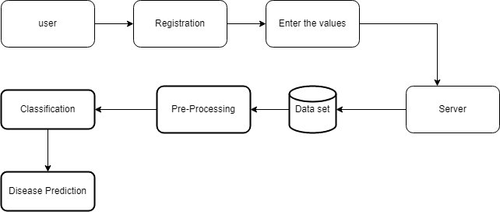

**User Stories**

Use the below template to list all the user stories for the product.

| **User Type** | **Functional Requirement (Epic)** | **User Story Number** | **User Story / Task** | **Acceptance criteria** | **Priority** | **Release** |
| --- | --- | --- | --- | --- | --- | --- |
| Customer | Registration | USN-1 | As a user, I can register for the application by entering my email, password, and confirming my password. | I can access my account / dashboard and enter the details | High | Sprint-1 |
|  |  | USN-2 | As a user, I will receive confirmation email once I have registered for the application | I can receive confirmation email & click confirm | High | Sprint-1 |
|  | Login | USN-3 | As a user, I can log into the application by entering email & password. | I can access my dashboard | High | Sprint-1 |
|  | Dashboard | USN-4 | User can View his/her medical report when the required parameter are enter. | I can see the result whether it is normal and abnormal. | Medium | Sprint-2 |
| Customer Care Executive |  | USN-5 | As Customer Care Executive ,The customer can view the frequently asked question. | I can post my queries in dashboard. | Medium | Sprint-2 |
|  |  |  | As a user he/she can update their details | I can update my account or details | High | Sprint-3 |
| Administrator |  | USN-6 | As a admin, he or she can delete or add the users | I can access the dashboard | High | Sprint-3 |
|  |  |  |  |  |  |  |